PL SQL
Exercise 1: Control Structures

Scenario 1: The bank wants to apply a discount to loan interest rates for customers above 60 years old.
  - Question: Write a PL/SQL block that loops through all customers, checks their age, and if they are above 60, apply a 1% discount to their current loan interest rates.
CODE:
-- Show loans before any changes
SELECT * FROM Loans;

BEGIN
FOR rec IN (
SELECT l.LoanID
FROM Loans l
JOIN Customers c ON l.CustomerID = c.CustomerID
WHERE c.Age > 60
) LOOP
UPDATE Loans
SET InterestRate = InterestRate - 1
WHERE LoanID = rec.LoanID;

DBMS_OUTPUT.PUT_LINE('Applied 1% discount to Loan ID: ' || rec.LoanID);
END LOOP;

COMMIT;
-- Show loans after discount

END;
/
SELECT * FROM Loans;
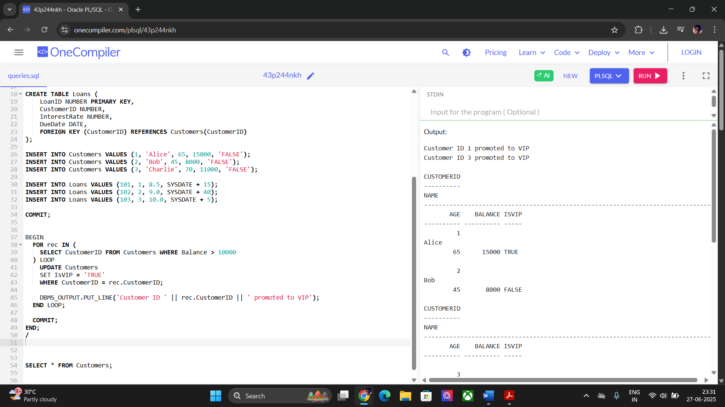
Scenario 2: A customer can be promoted to VIP status based on their balance.
  - Question: Write a PL/SQL block that iterates through all customers and sets a flag IsVIP to TRUE for those with a balance over $10,000.
CODE:
BEGIN
FOR rec IN (
SELECT CustomerID FROM Customers WHERE Balance > 10000
) LOOP
UPDATE Customers
SET IsVIP = 'TRUE'
WHERE CustomerID = rec.CustomerID;

DBMS_OUTPUT.PUT_LINE('Customer ID ' || rec.CustomerID || ' promoted to VIP');
END LOOP;

COMMIT;
END;
/
Scenario 3: The bank wants to send reminders to customers whose loans are due within the next 30 days.
  - Question: Write a PL/SQL block that fetches all loans due in the next 30 days and prints a reminder message for each customer.
CODE:
BEGIN
FOR rec IN (
SELECT c.Name, l.DueDate
FROM Loans l
JOIN Customers c ON l.CustomerID = c.CustomerID
WHERE l.DueDate BETWEEN SYSDATE AND SYSDATE + 30
) LOOP
DBMS_OUTPUT.PUT_LINE('Reminder: ' || rec.Name || ', your loan is due on ' || TO_CHAR(rec.DueDate, 'DD-MON-YYYY'));
END LOOP;
END;
/
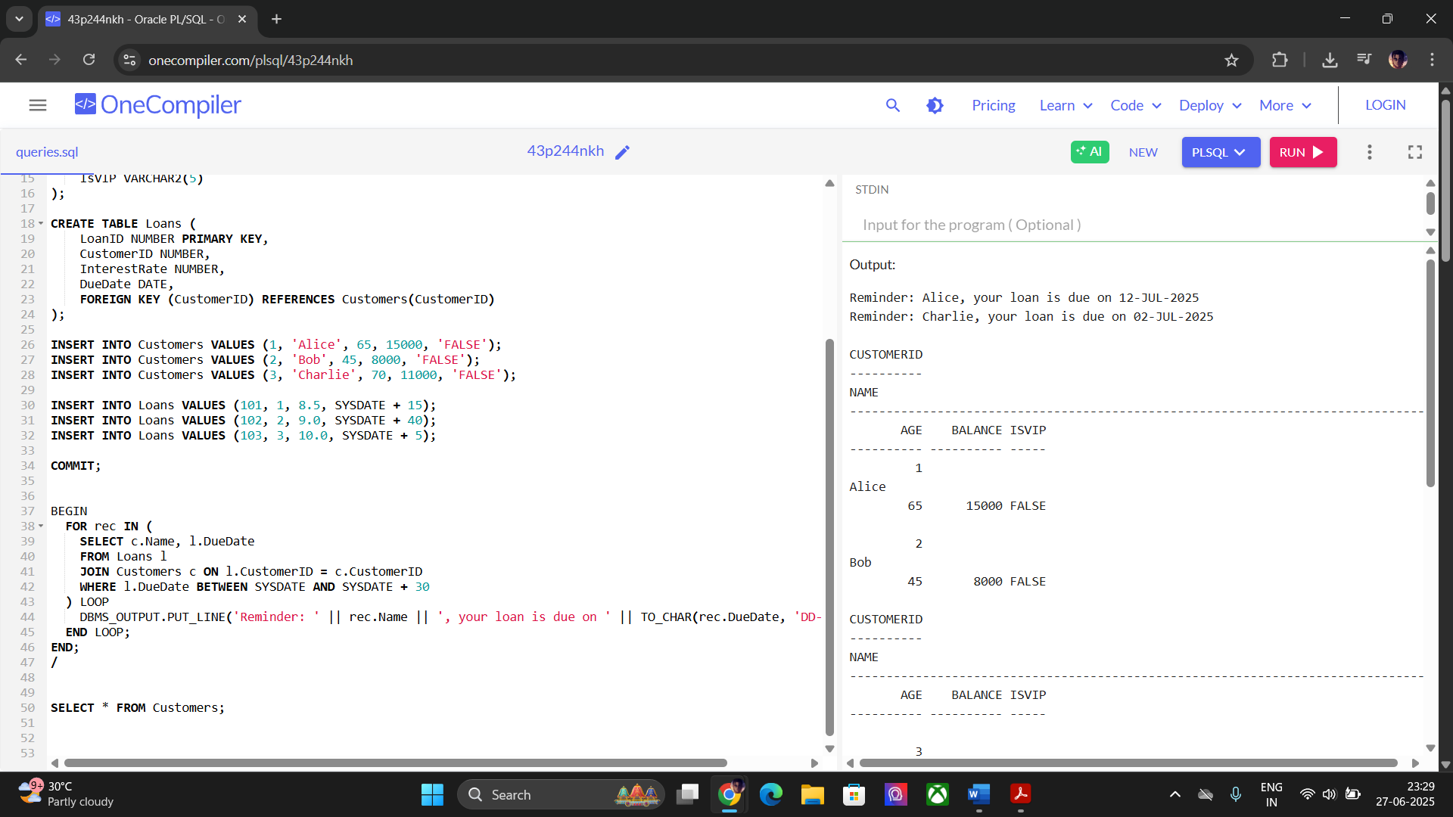
Exercise 3: Stored Procedures

Scenario 1: The bank needs to process monthly interest for all savings accounts.
  - Question: Write a stored procedure ProcessMonthlyInterest that calculates and updates the balance of all savings accounts by applying an interest rate of 1% to the current balance.
CODE:
CREATE OR REPLACE PROCEDURE ProcessMonthlyInterest IS
BEGIN
FOR rec IN (
SELECT AccountID, Balance FROM Accounts WHERE AccountType = 'Savings'
) LOOP
UPDATE Accounts
SET Balance = Balance + (rec.Balance * 0.01)
WHERE AccountID = rec.AccountID;

DBMS_OUTPUT.PUT_LINE('Interest added to Account ID: ' || rec.AccountID);
END LOOP;

COMMIT;
END;
/

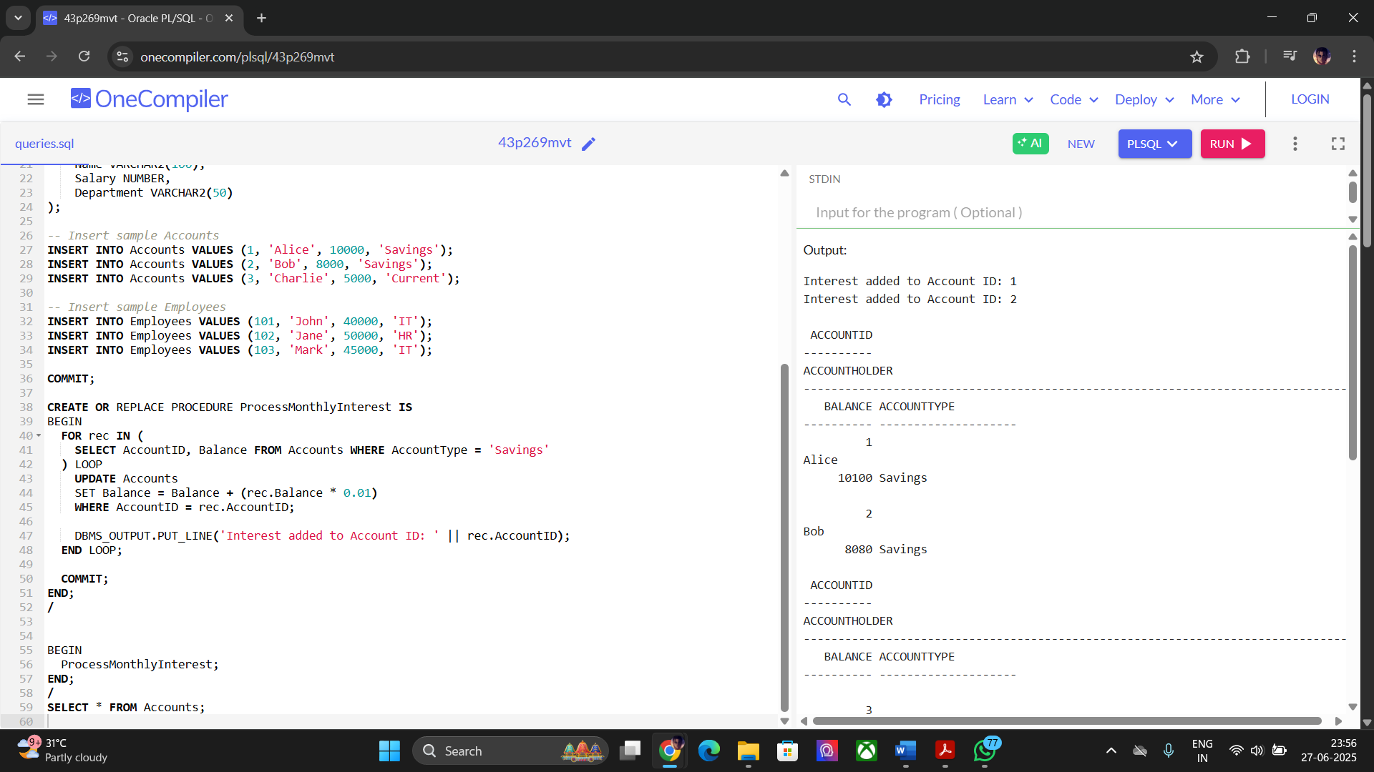

Scenario 2: The bank wants to implement a bonus scheme for employees based on their performance.
  - Question: Write a stored procedure UpdateEmployeeBonus that updates the salary of employees in a given department by adding a bonus percentage passed as a parameter.
CODE:
CREATE OR REPLACE PROCEDURE UpdateEmployeeBonus(
p_department IN VARCHAR2,
p_bonus_pct IN NUMBER
) IS
BEGIN
FOR rec IN (
SELECT EmpID, Salary FROM Employees WHERE Department = p_department
) LOOP
UPDATE Employees
SET Salary = Salary + (rec.Salary * p_bonus_pct / 100)
WHERE EmpID = rec.EmpID;

DBMS_OUTPUT.PUT_LINE('Bonus applied to EmpID: ' || rec.EmpID);
END LOOP;

COMMIT;
END;
/

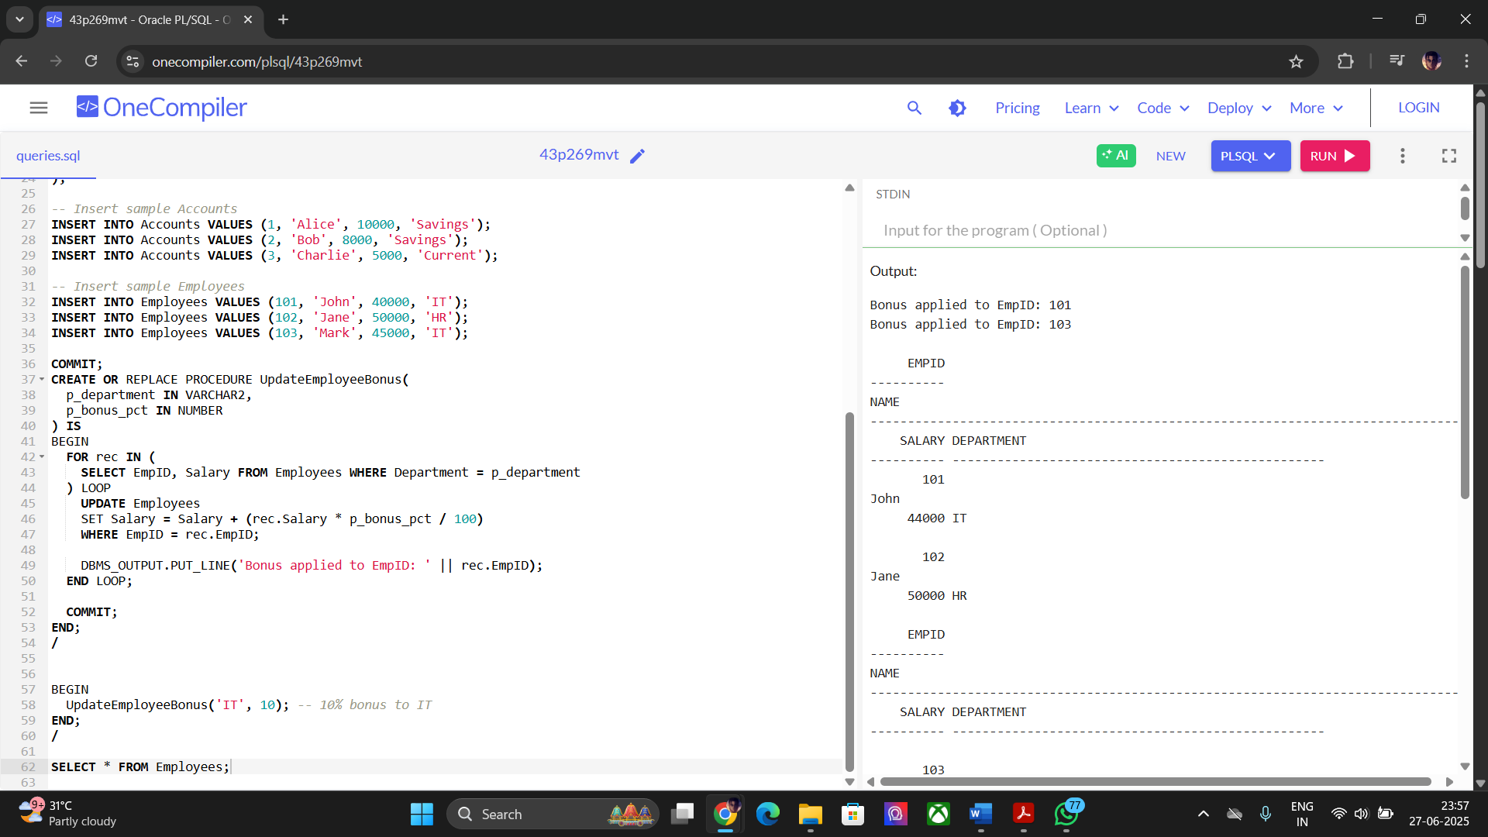

Scenario 3: Customers should be able to transfer funds between their accounts.
Question: Write a stored procedure TransferFunds that transfers a specified amount from one account to another, checking that the source account has sufficient balance before making the transfer.
CODE:
CREATE OR REPLACE PROCEDURE TransferFunds(
p_from_account IN NUMBER,
p_to_account IN NUMBER,
p_amount IN NUMBER
) IS
v_balance NUMBER;
BEGIN
SELECT Balance INTO v_balance FROM Accounts WHERE AccountID = p_from_account;

IF v_balance < p_amount THEN
RAISE_APPLICATION_ERROR(-20001, 'Insufficient balance for transfer');
END IF;

-- Deduct and add funds
UPDATE Accounts SET Balance = Balance - p_amount WHERE AccountID = p_from_account;
UPDATE Accounts SET Balance = Balance + p_amount WHERE AccountID = p_to_account;

DBMS_OUTPUT.PUT_LINE('Transferred ' || p_amount || ' from Account ' || p_from_account || ' to Account ' || p_to_account);

COMMIT;
EXCEPTION
WHEN OTHERS THEN
ROLLBACK;
DBMS_OUTPUT.PUT_LINE('Error: ' || SQLERRM);
END;
/

